**VAISHALI BOKADIYA**

**AZURE DATABRICKS**

**CODING ASSESSMENT**

**QUESTION 3**

**Question 3**

**Execute & explain, Azure data factory and its copy activity.**

**Azure Data Factory**

Azure Data Factory is a data integration solution for ingesting, preparing, and transforming all your data at scale.

It allows you to create data driven workflows. The data factory service allows you to create and run data pipelines that move and transform data.

Azure Data Factory pipelines perform the following 3 steps:

1. Connect and collect
2. Transform and Enrich
3. Publish

**Copy Activity**

Copy activity in Azure Data Factory migrates or copies data between two cloud based data stores or between a cloud based data store and an on premise data store.

It copies the data from source data store to the destination data store.

**To perform data migration or copy activity in Azure data factory,**

**Perform the following steps:**

Open Azure and create two azure storage accounts, create container in both and upload some file in one container which are to be copied into the other one.

Now search data factories in Azure

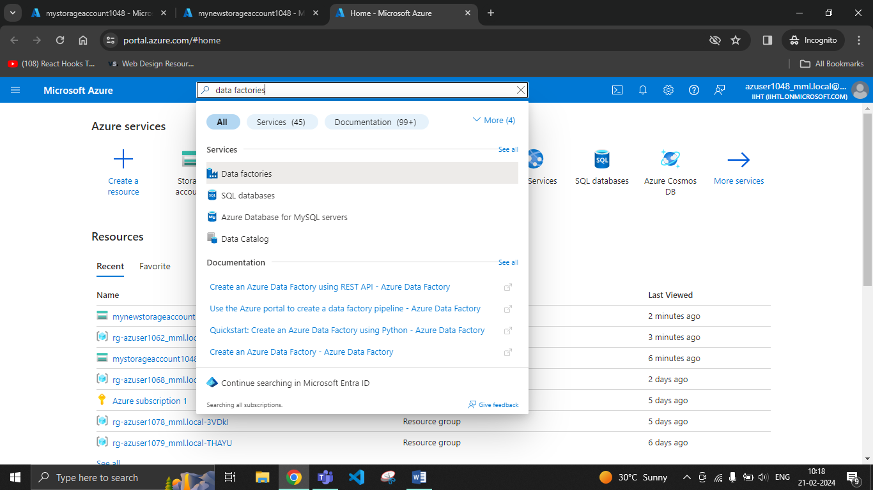

Go to create

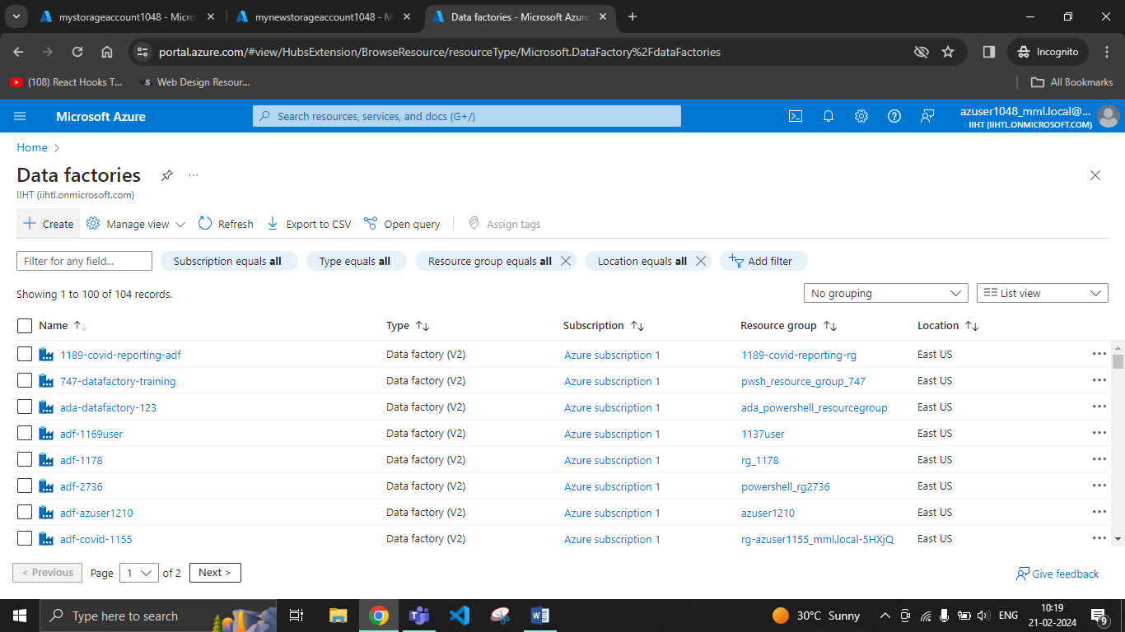

Go to review and create

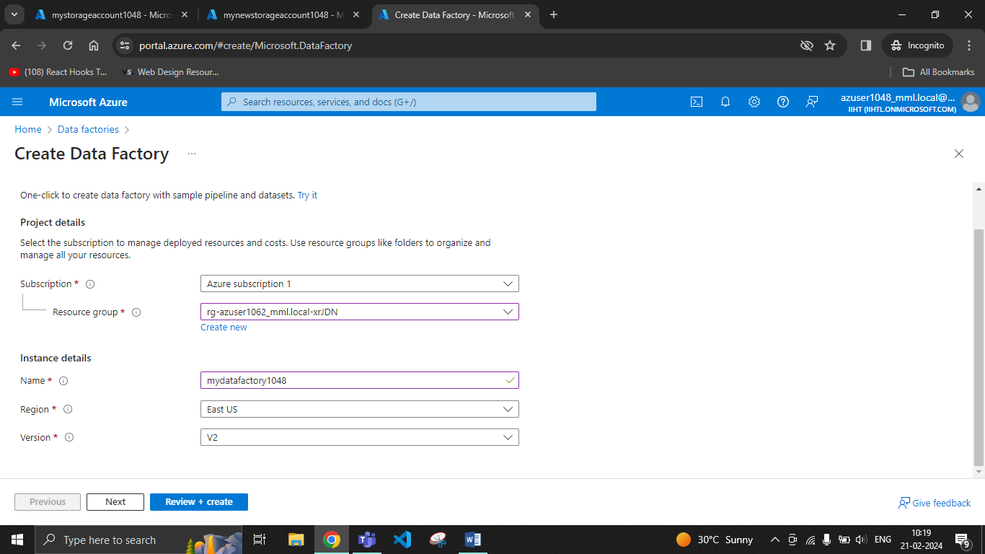

Go to resource

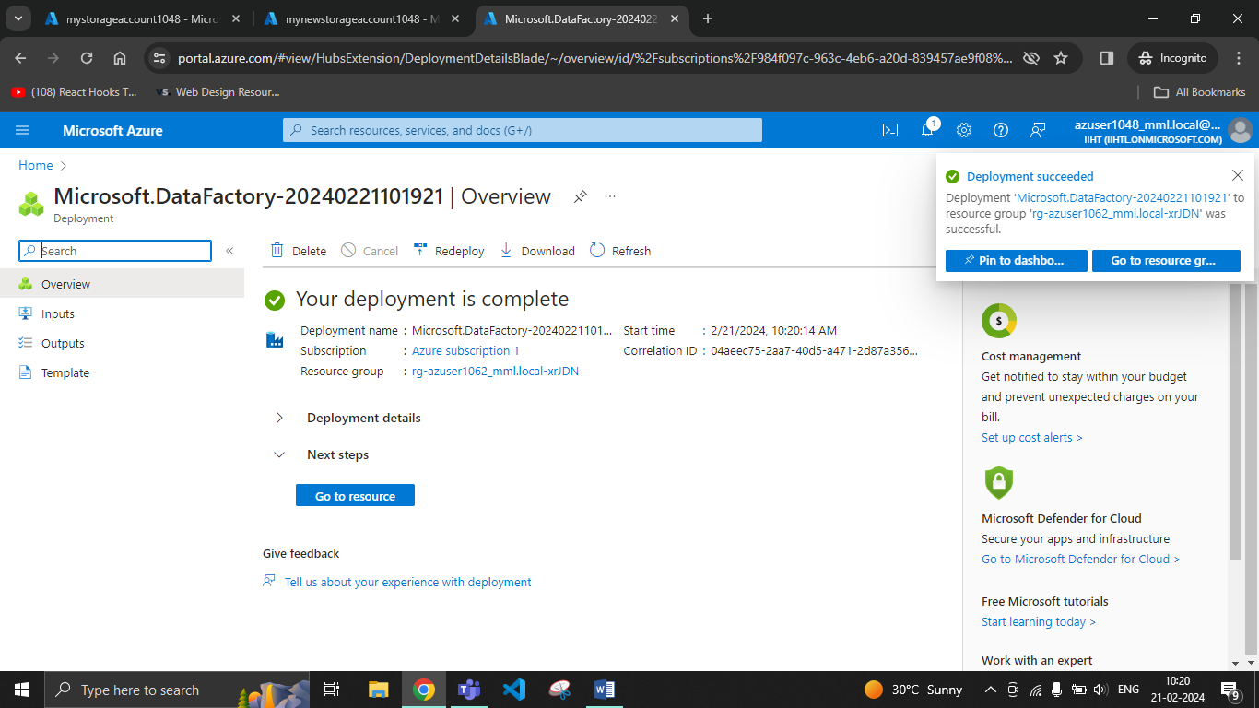

Launch Studio

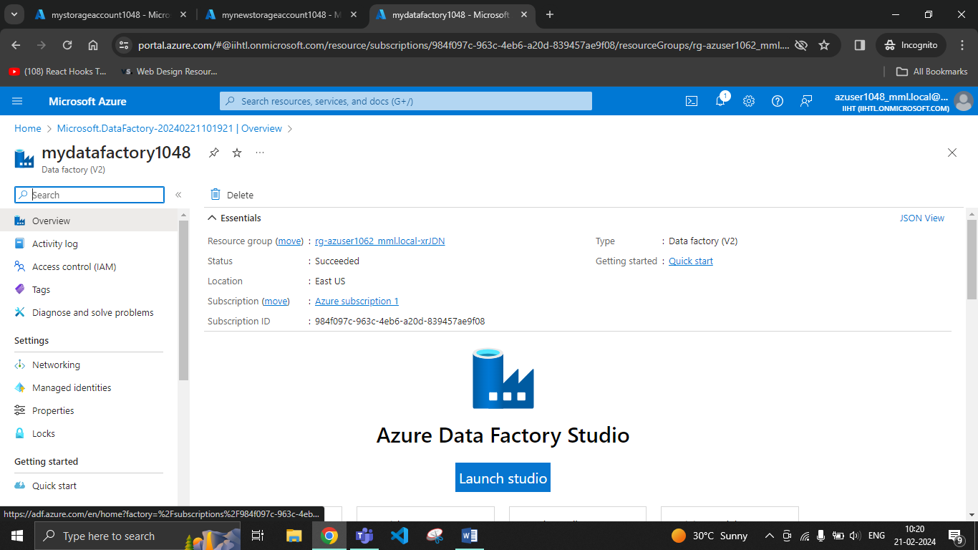

Go to ingest

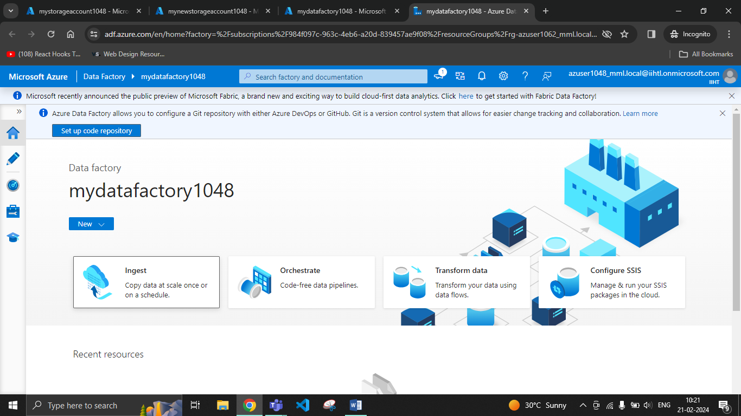

Click on next

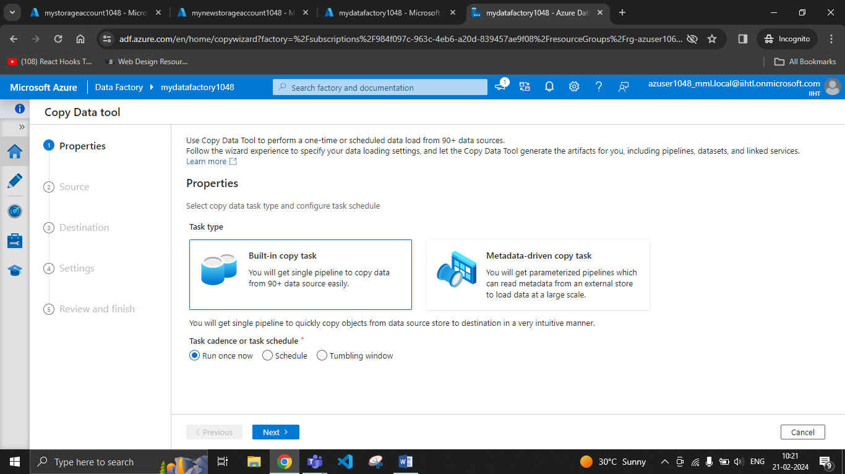

Create a new connection

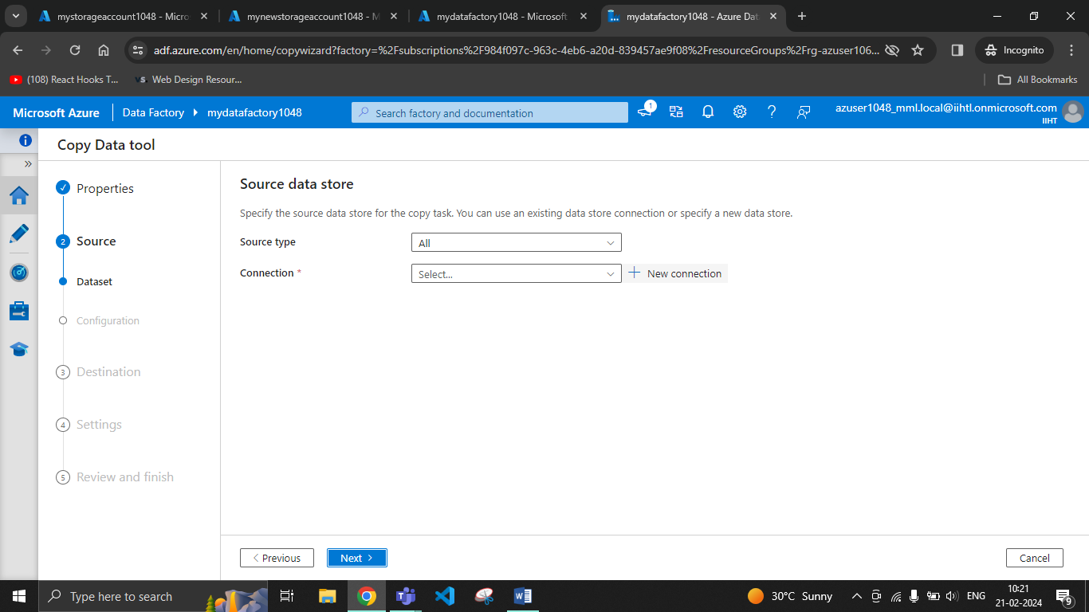

Select Azure blob storage

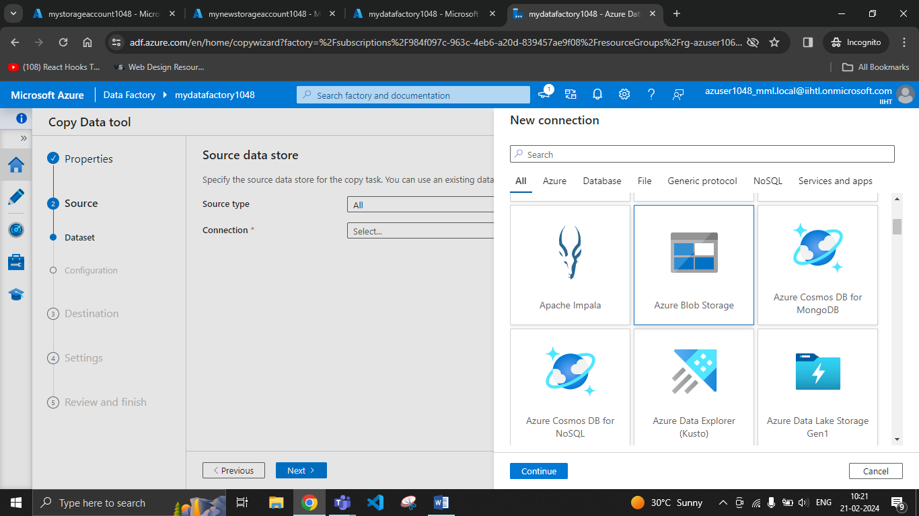

Select your storage account, check the connection and create.

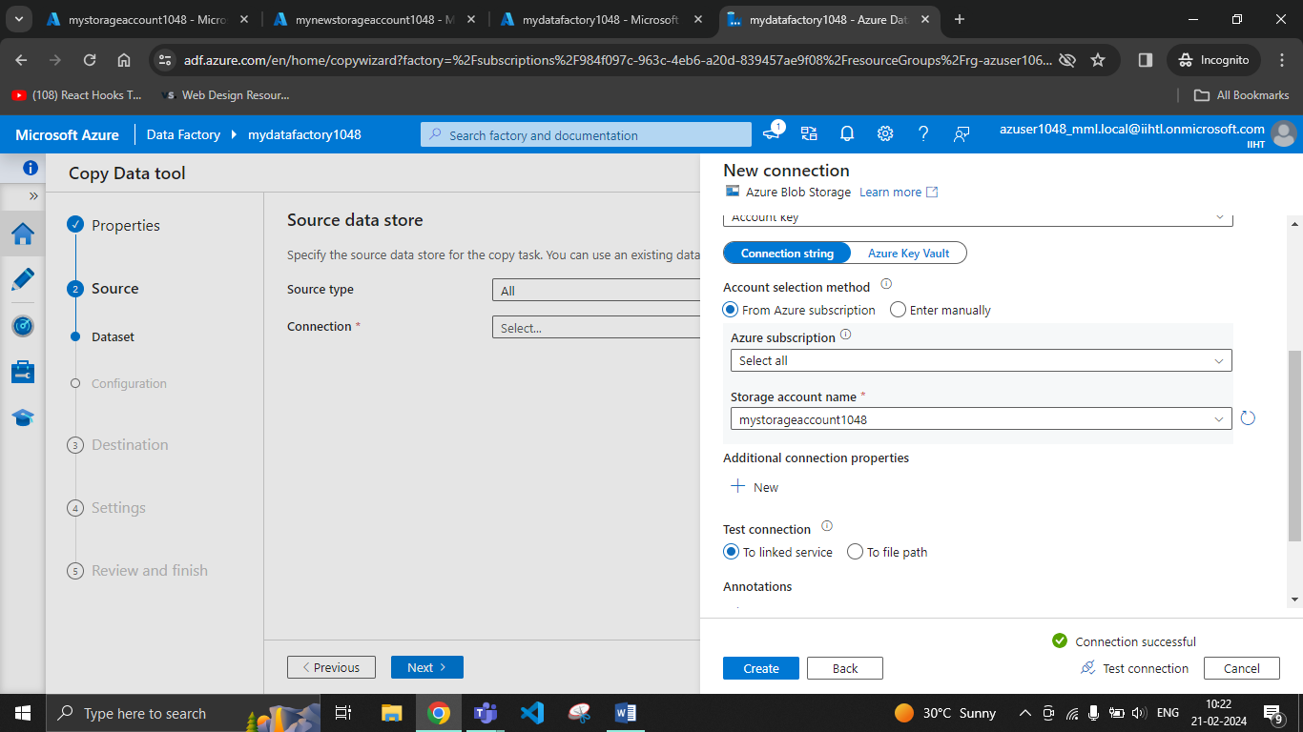

Browse the folder which contains the files to be copied

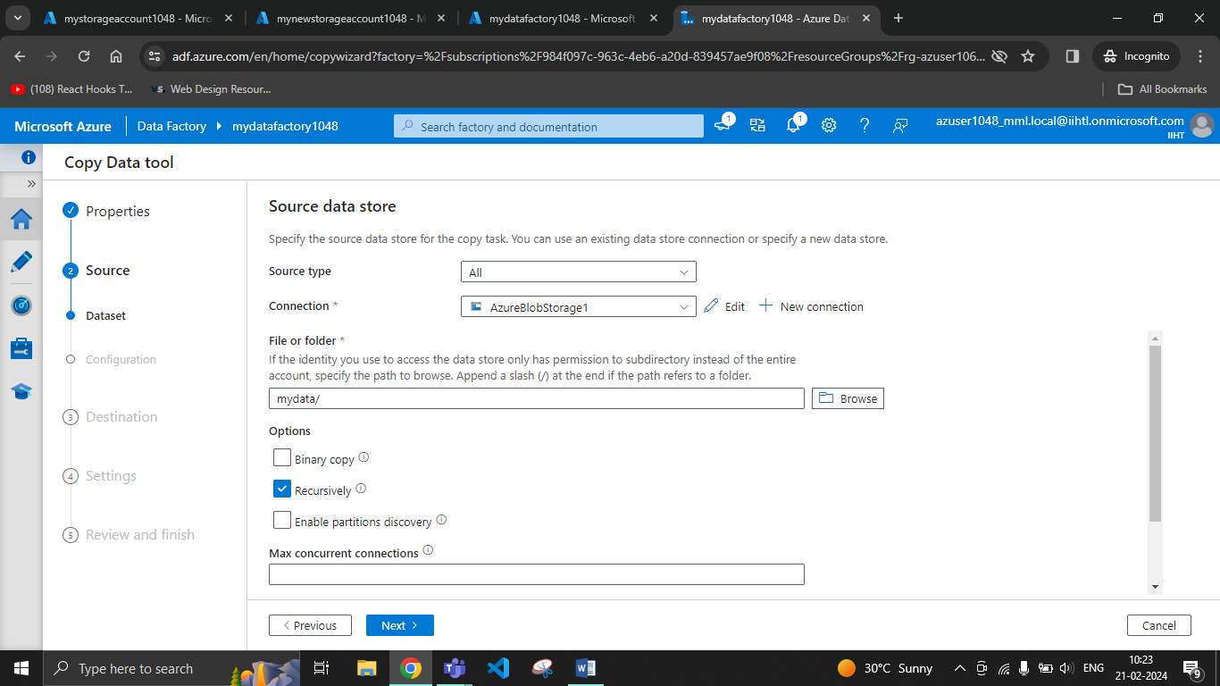

Go to next

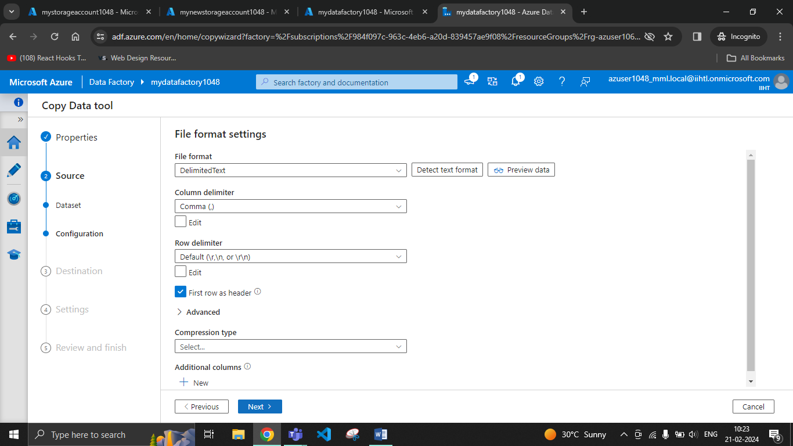

Create a new connection

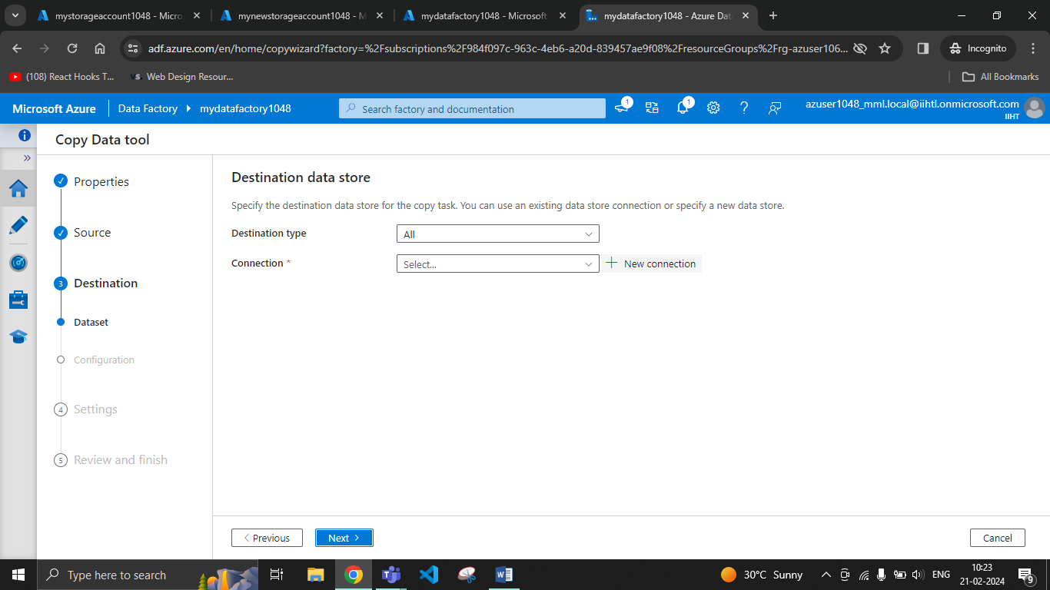

Select Azure Blob Storage

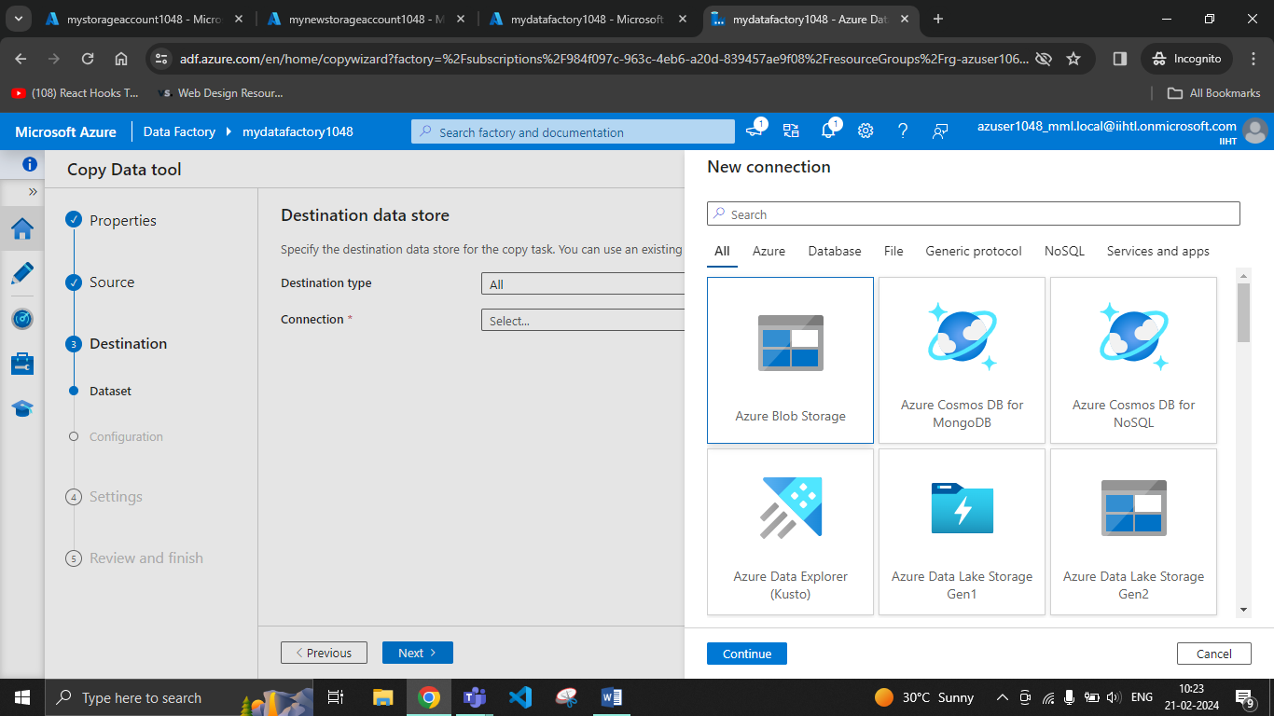

Select your Azure Storage Account in which the files has to be copied.

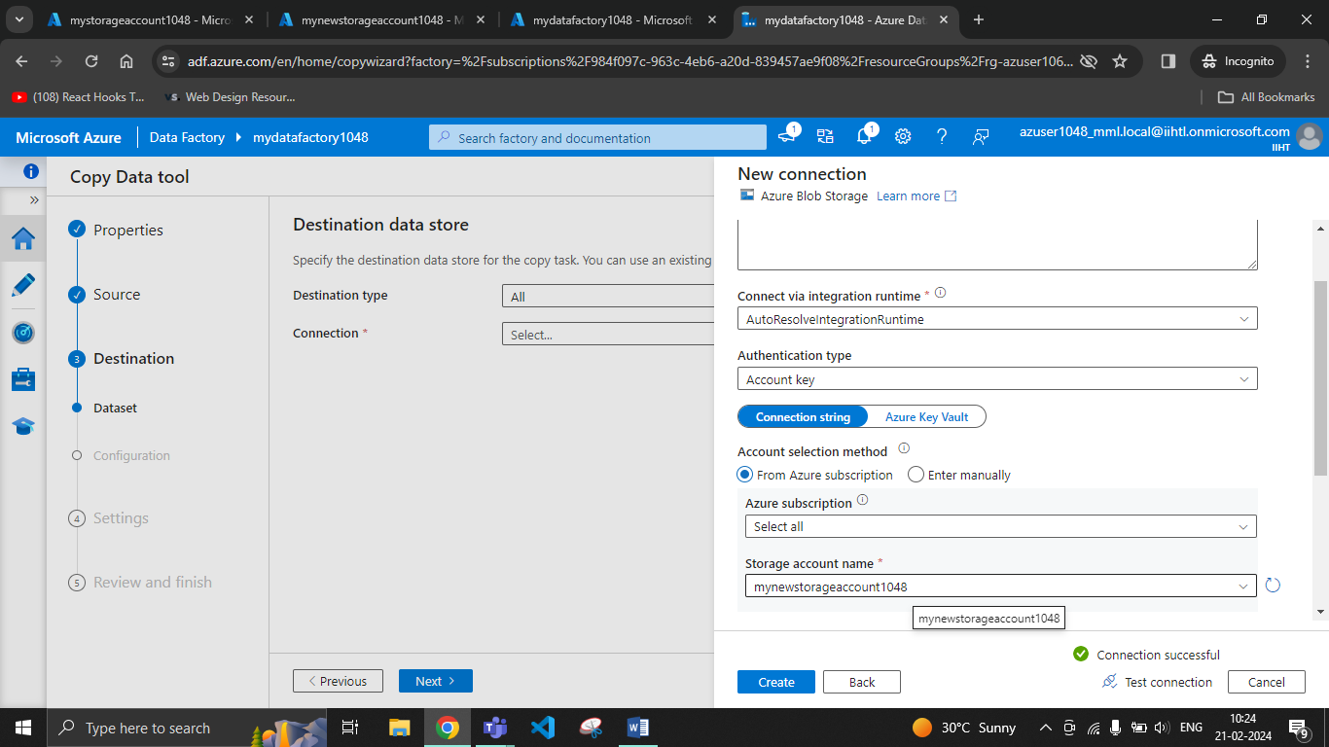

Browse the folder in which the files has to be copied

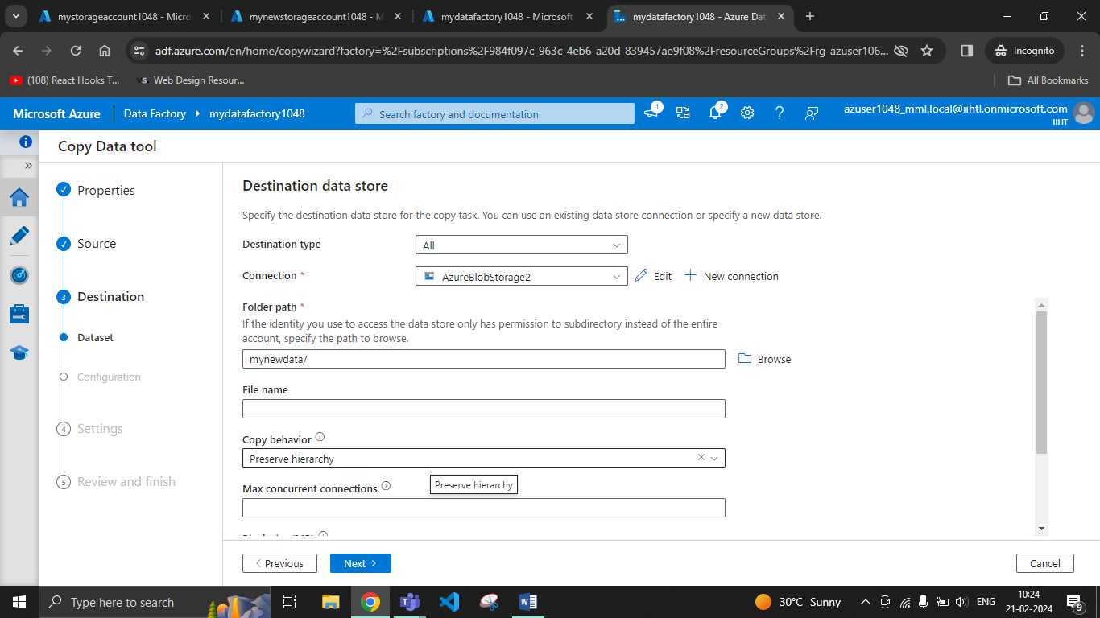

Go to next

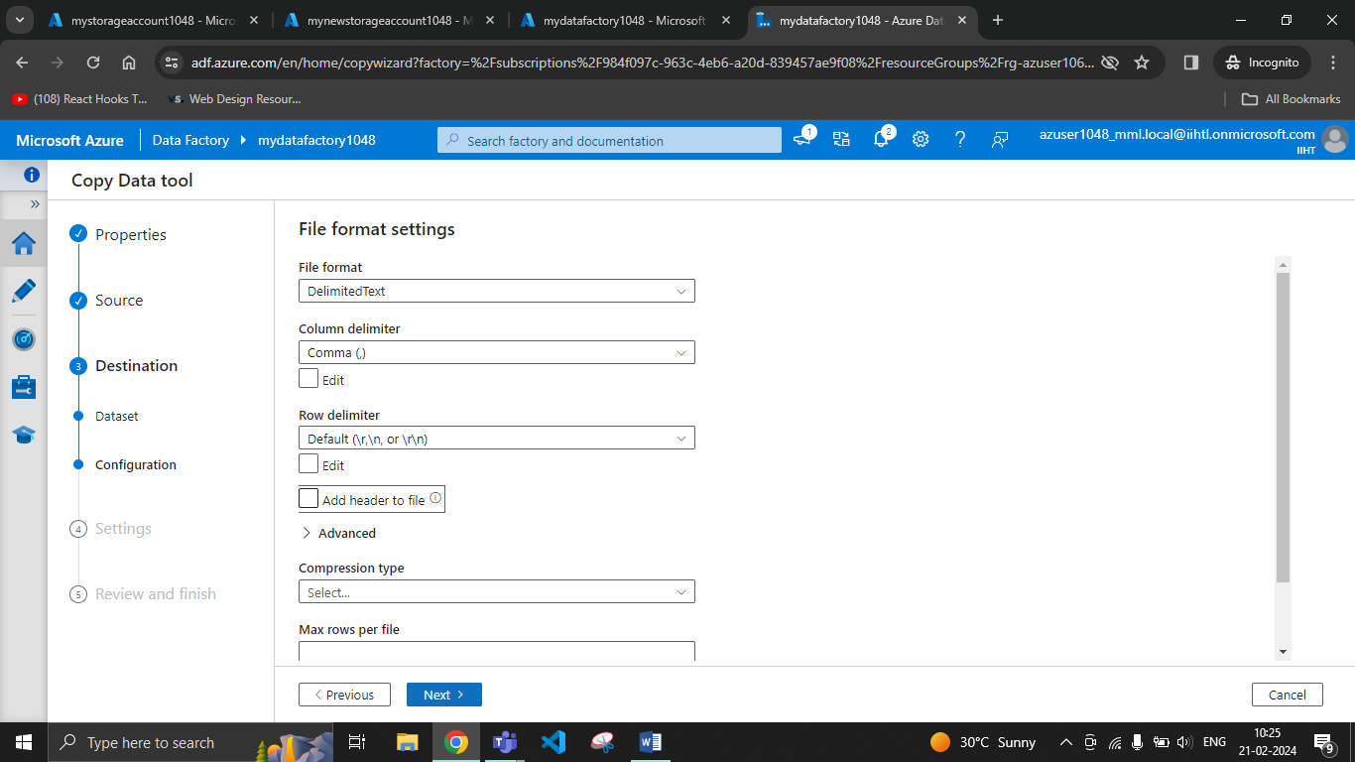

Fill the description and go to next

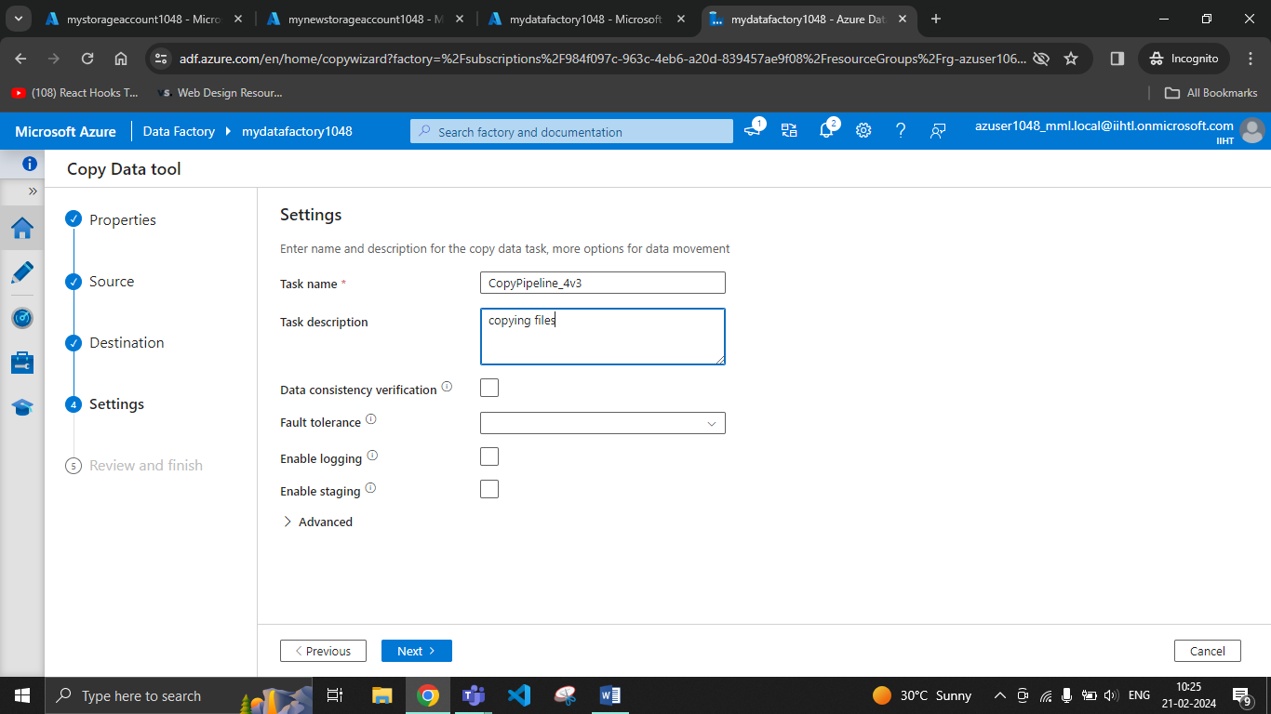

Review and go to next

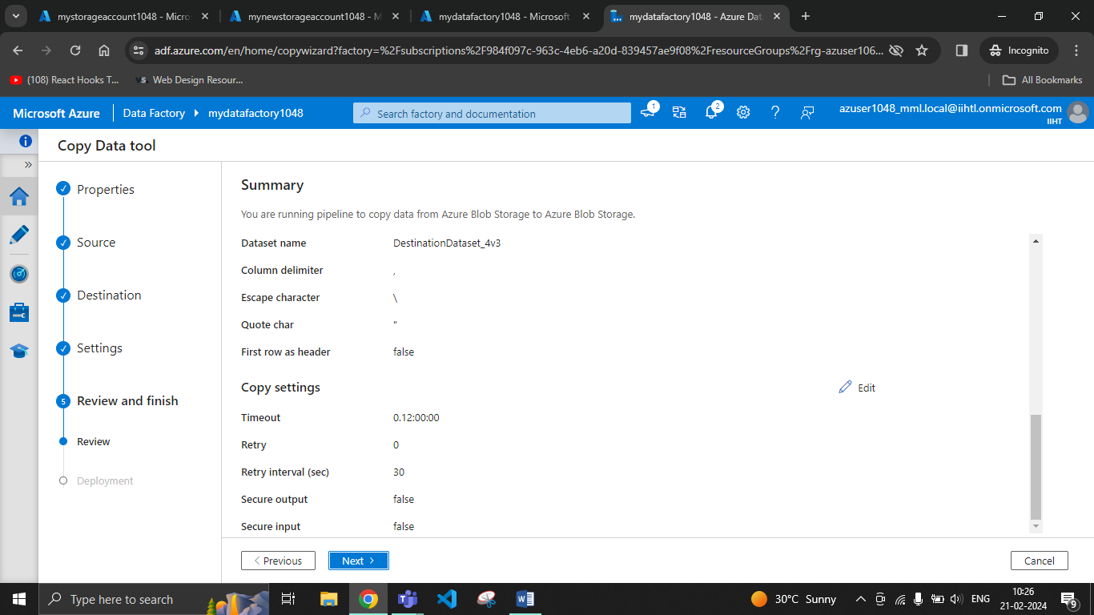

Click on finish

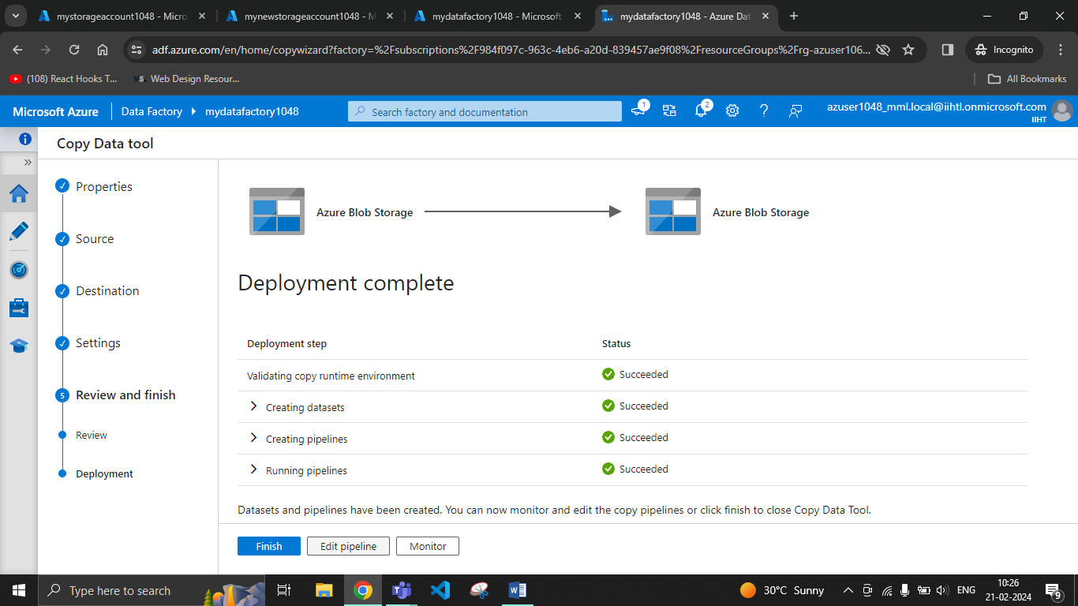

Files have been copied to the destination

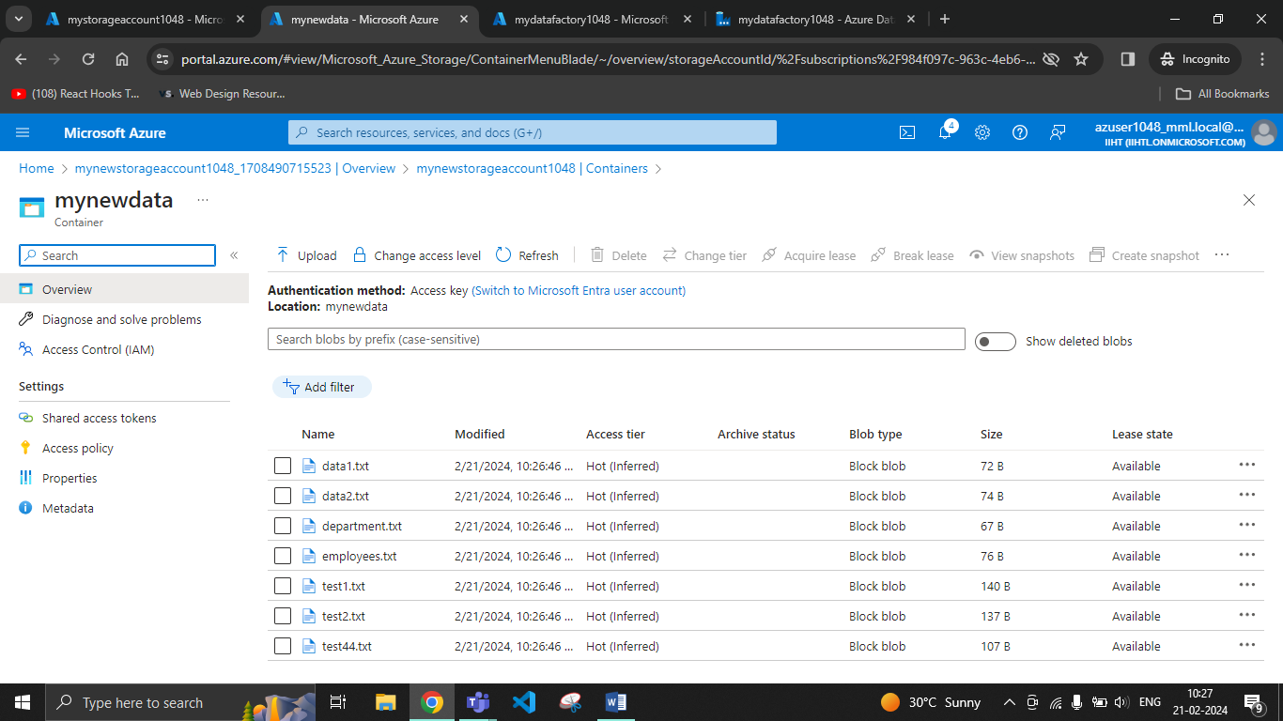

Go to monitor and pipelines run, you can rerun the pipeline from here

